Role Profile: Berkshire Retail Volunteer

Why is this role important?
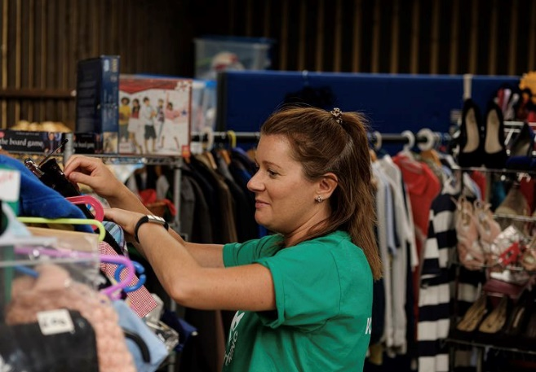
Our onsite shops couldn’t operate successfully without our amazing volunteers. You would be working alongside our retail coordinator and as part of a team to create an enjoyable shopping experience for all customers and most importantly to raise as much money as possible for NAWTs work to rescue and rehome animals.
What will you gain in return?
How can you support us?
- Keeping the shops clean and tidy.
- Sorting and preparing stock ready for sale.
- Replenishing stock.
- Assisting the Retail Coordinator to price and rotate stock.
- Assisting the Retail Coordinator to make changes to the shop layout and create exciting displays.
- An opportunity to make a real difference to the future of NAWT.
- The chance to learn new skills with training provided.
- A chance to use and enhance your current skills and experience.
- Meet new people and make friends along the way.
Ideally, you will….
- Have good communication skills and enjoy meeting members of the public.
- Like to experience new things.
- Enjoy working individually and as part of a team.
- Have a passion for retail and sales.
- Be reliable and have an interest in the work of the trust.
When do we need you?
- Flexible. We have shifts to suit everybody’s needs! Please see our website for availability

