Role Profile: Volunteer Driver - Retail

Why is this role important?
Our shops can’t run without a continuous supply of stock, and being able to move stock around between our various outlets is invaluable to us and means we can continue to raise funds to make a difference to the animals in our care.

How you can support us:
- Collect and deliver stock around our shops.
- Transport stock between our shops and their storage units based at their local rescue
Centres.
- Some lifting of donated furniture items and sorting of stock.
- Some off-site collections from companies offering donations of stock.
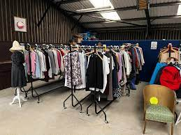

What can you gain in return?
- An opportunity to engage with and support the local community, making a difference to the lives of animals.
- A chance to learn new skills.
- Enhancing your current skills and experience.
- The chance to join a great team and make new friends along the way.

When do we need you?
- Flexible. We have shifts to suit everybody’s needs.
Ideally, you will….
- Have good communication skills and enjoy meeting people.
- Have a full, clean driving licence.
- Be able to donate 1 day or more per week to this role.

